**Assignment No: 10**

**Deploy a project from GitHub to EC2 by creating a new security group and user data.**

**Solution:**

**Step 1:** Upload required files to GitHub

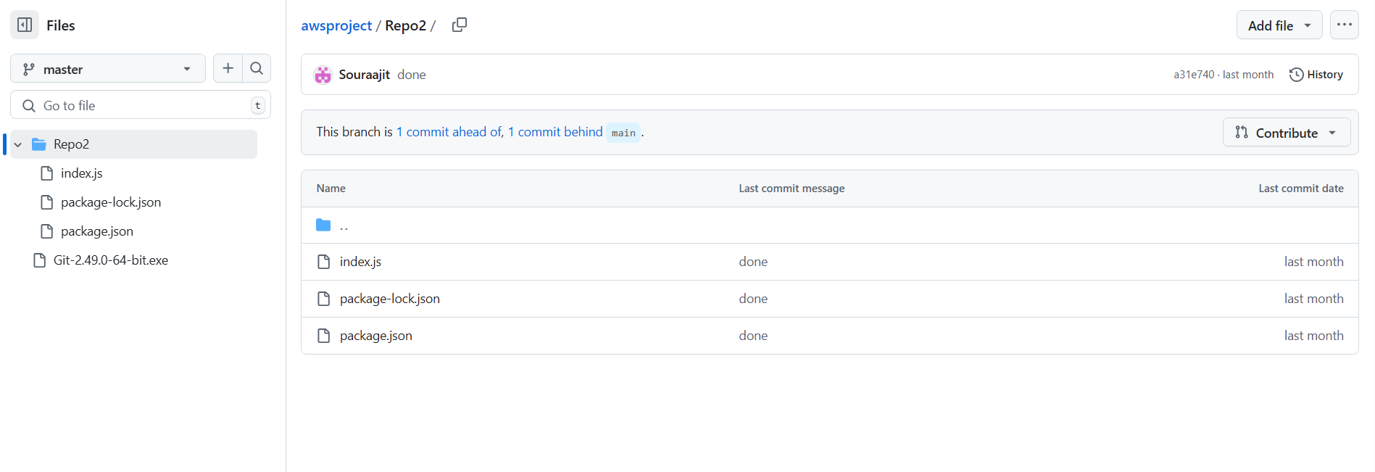

**Step 2:** Log into AWS and open EC2.Then open the security groups from network and security in the left side and select all the security group except default and delete them then click on create security group.

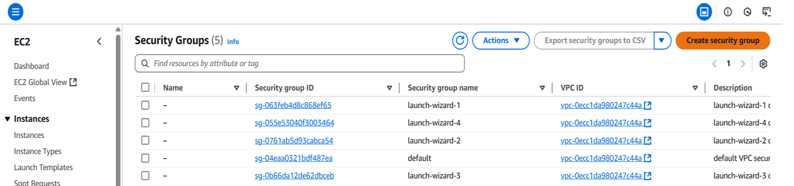

**Step 3:** Click on Create security group then give a name and description of the security group and set up all inbound rules. Include SSH, HTTP, HTTPS and custom TCP then click on save rules.

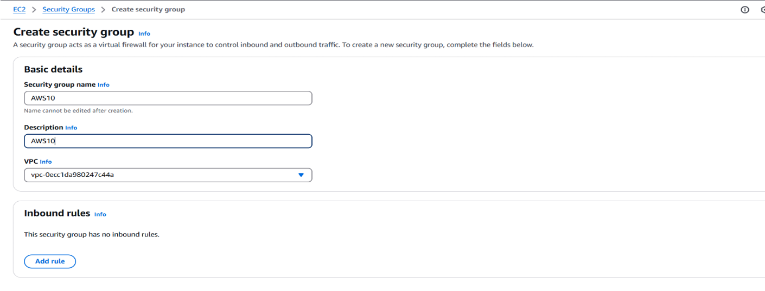

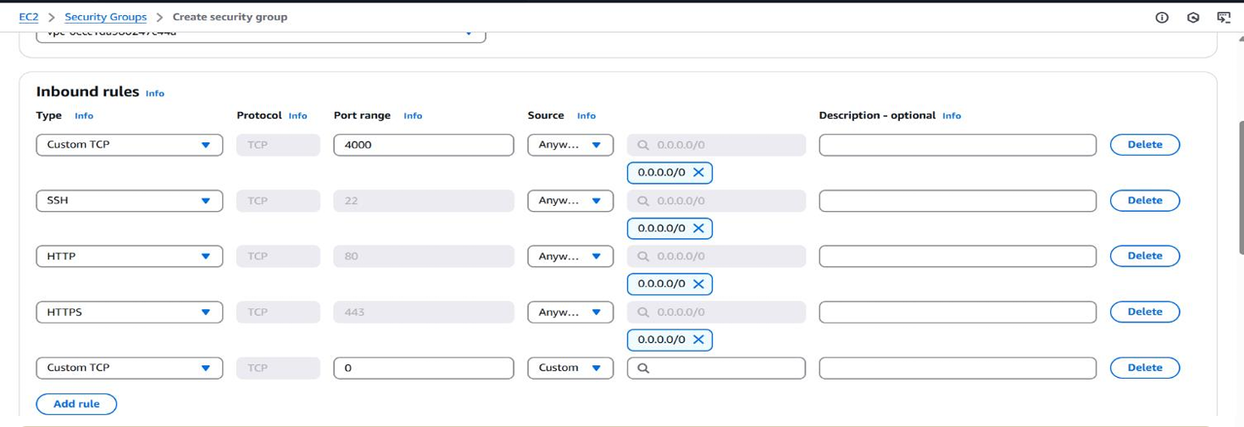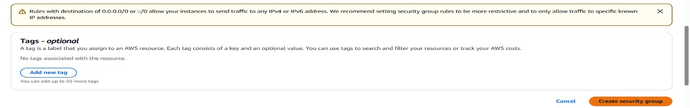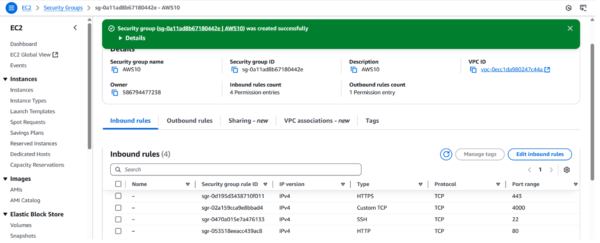

**Step 4:** Click on launch instance. Give a name to the instance and select the operating system as Ubuntu.

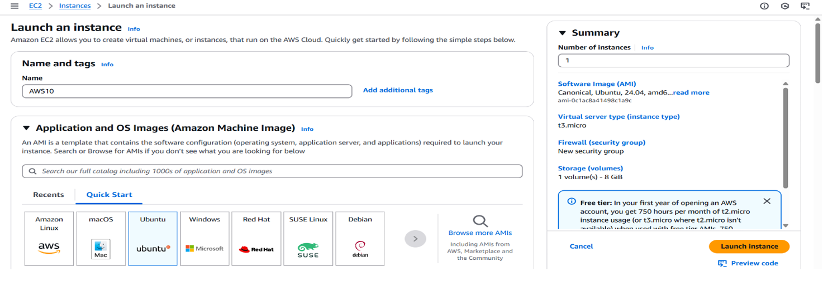

**Step 5:** Create Key Pair.

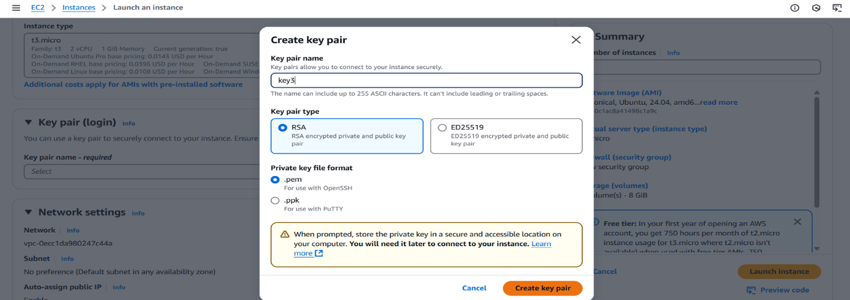

**Step 6:** From the Network Section Select Existing Security Group then choose your previously created security group.

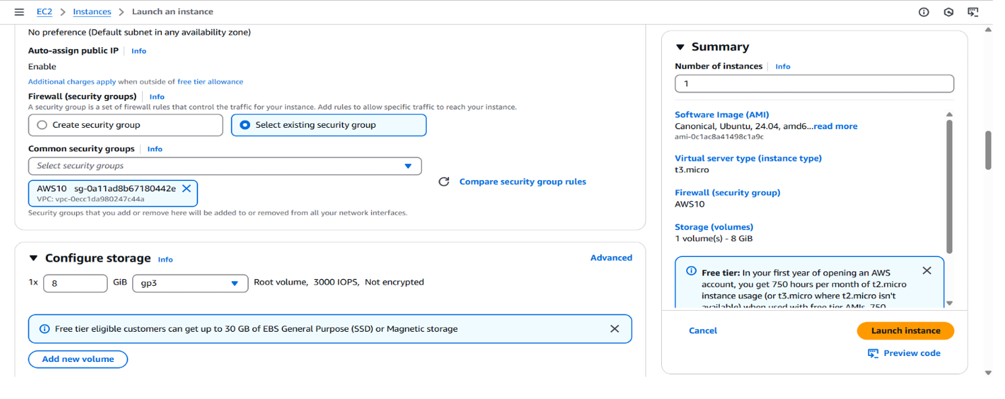

**Step 7:** After Selecting security group go to the user data section and write given cmd. and click launch instance.

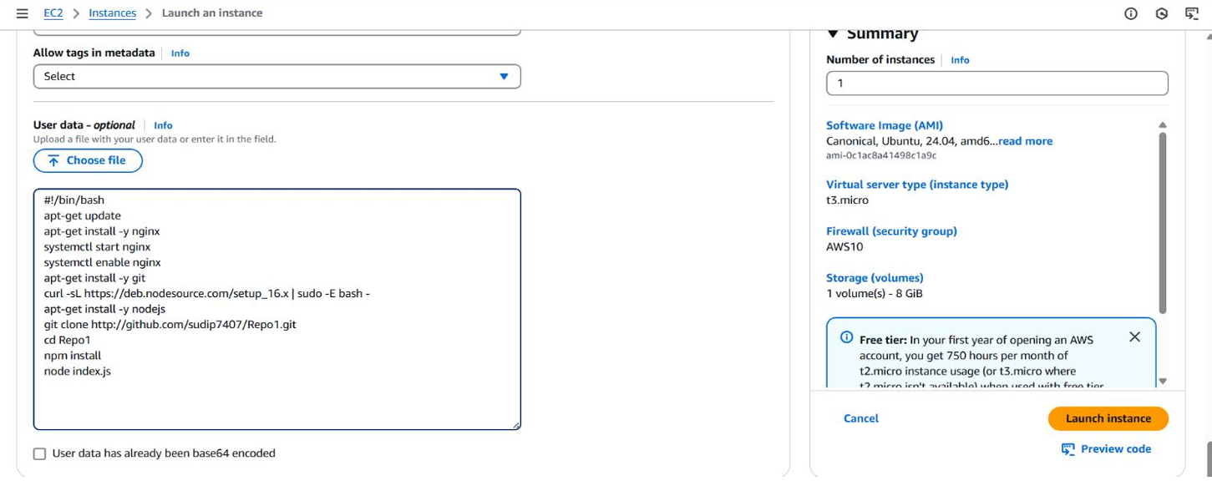

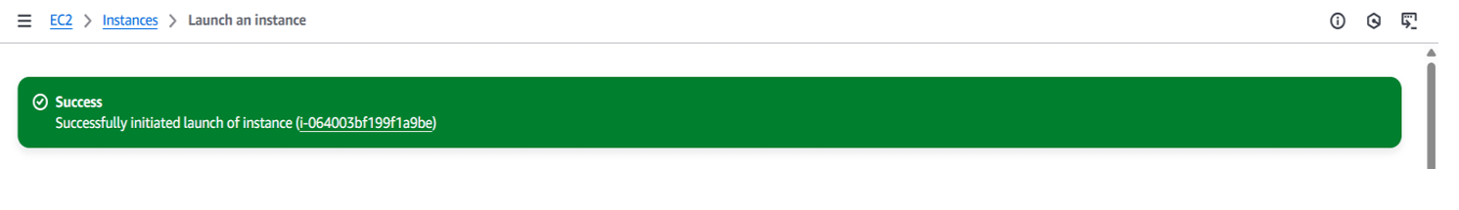

**Step 7:** Open Bitwise SSH Client and paste the IP address in host and set up authentication using the key pair then login and after logging in open new terminal window.

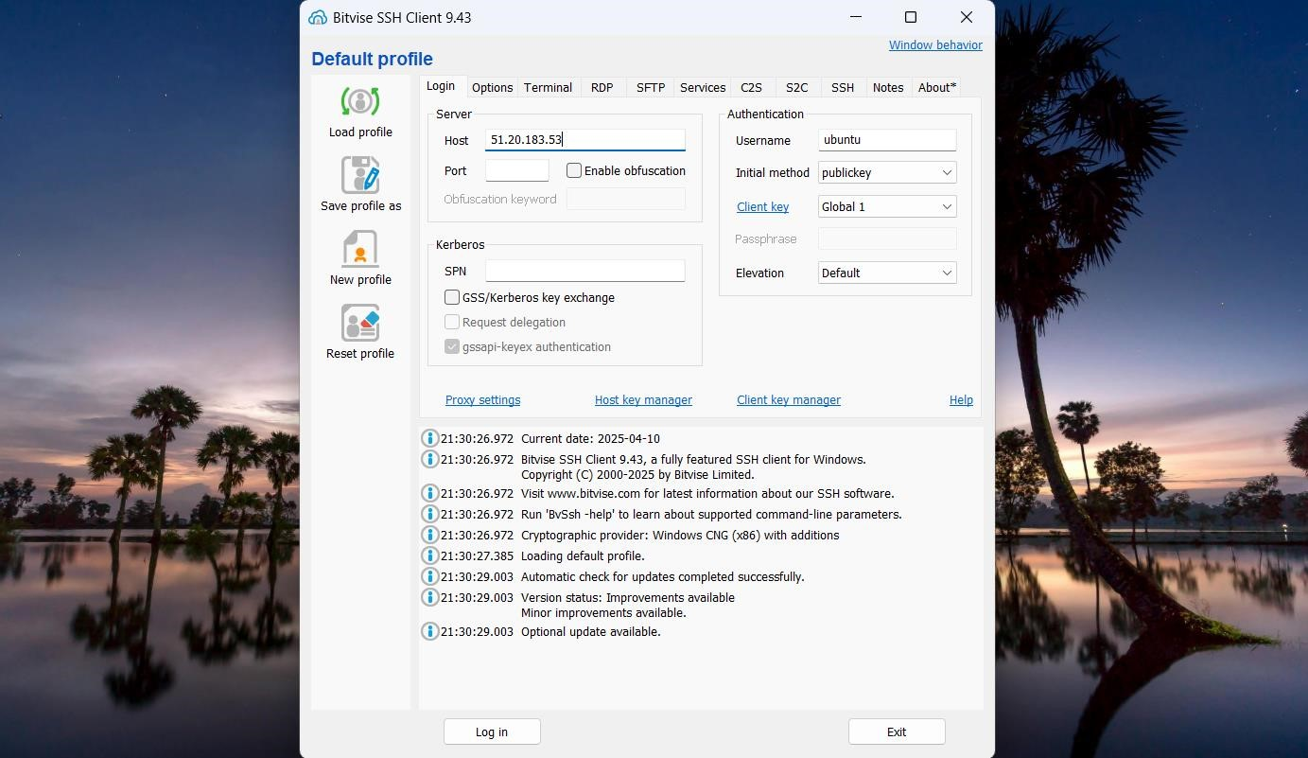

**Step 8:** Now clone the GitHub repository from GitHub using command git clone paste the link of the repository. Now execute Sudo apt install node.js and npm install.

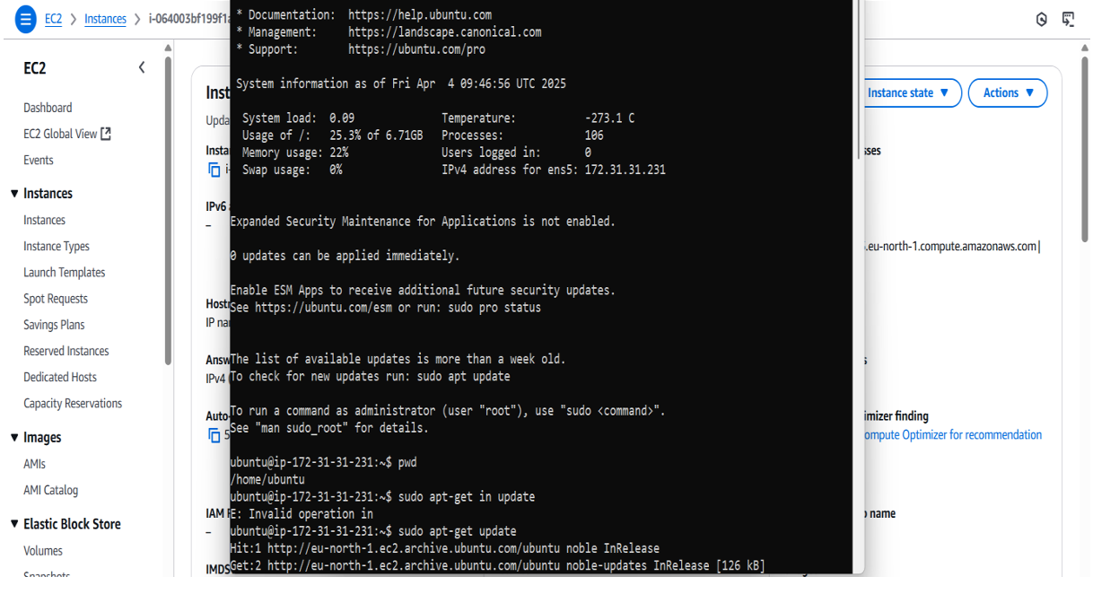

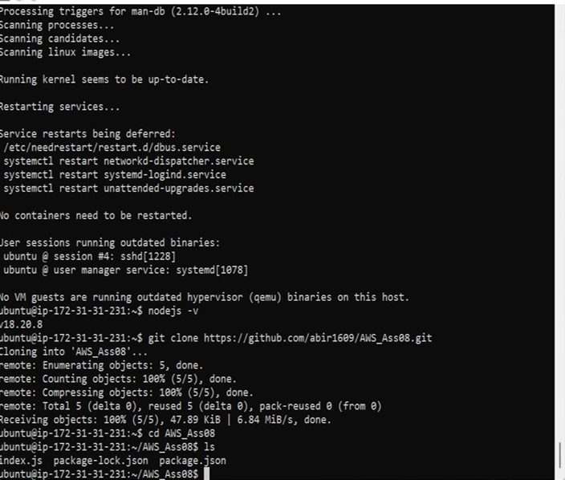

**Step 11:** Open the Bitvise SSH Client terminal console and start the server using command node index.js

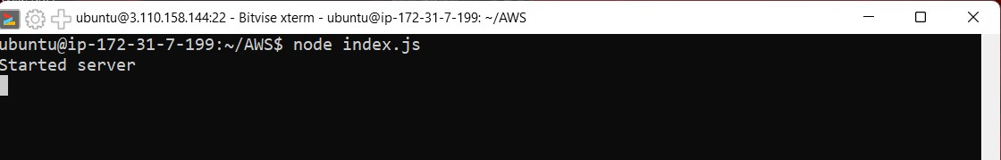

**Step 12:** Now copy the IPv4 address of the instance and paste it on web browser.

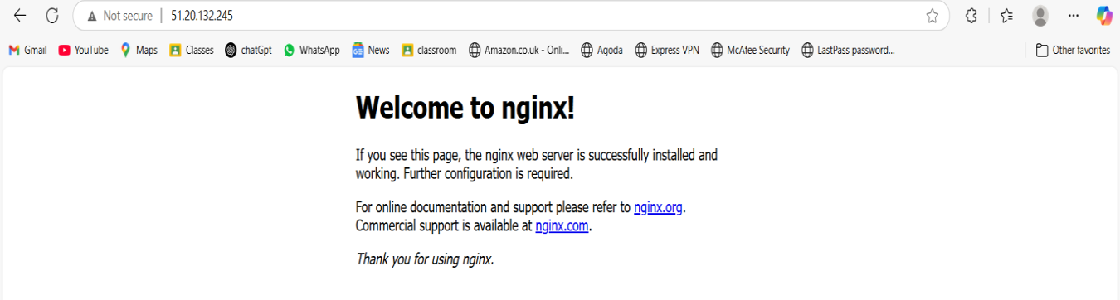

**Step 13:** Then, put the port like this IP address: Port (51.20.183.53:4000)

